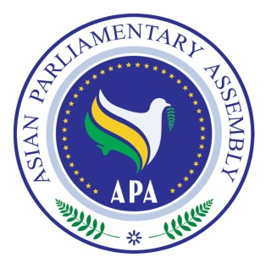


Asian Parliamentary Assembly
Standing Committee Meeting on Staff and Financial Regulations

21-24 May 2017
Abu Dhabi, United Arab Emirates

Draft Agenda
1- Adoption of the Agenda
2- Election of the Bureau
3- Opening Remarks by the Chairperson
4- Report by H.E. Dr. Ali Khorram, Deputy Secretary General of APA
5- Consideration and recommendation of Draft Resolution on Planning APA Budget for 2018
6- Any other matter.

As of 2 May 2017

